



MODEL
SYH-290
DOUGH ROUNDING MACHINE
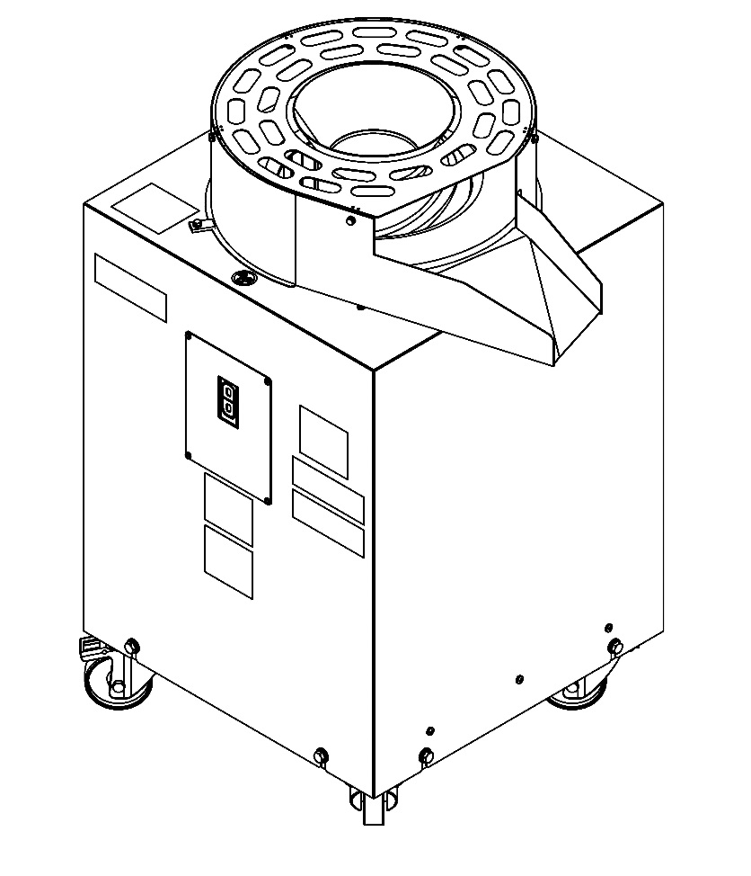

USER & MAINTENANCE MANUAL

ŞENGÜN MAKİNA İNŞAAT ve KIRTASİYE SAN. TİC. LTD. ŞTİ


WARRANTY CERTIFICATE
SERIAL NUMBER:
SALE DATE:
Sold at the above date SHY-290 MODEL DOUGH ROUNDING MACHINE is guaranteed against production failures for 1 Year by ŞENGÜN MAKİNA İNŞAAT and KIRTASİYE SAN. TİC. LTD. ŞTİ.

Warranty Terms;
- Warranty terms start after the product delivery for 1 year.
- Recommended daily working time is 10 hours. The scope of warranty is assessed by year or by working hours.
- Documents are invalid, if haven’t sale date and confirm signature of company. You have to show the warranty certificate to benefit from the warranty.
- Device is guaranteed against defects if mount and use as described ın the use and maintenance manual.
- Detection the location of defects, and elimination of the problems are responsibilities of the ŞENGÜN MAKİNA
- Warranty terms includes only one device. You can’t claim any rights or compensation for another devices.
- If Changes are made at the type, model and serial numbers, the warranty eliminates.
- If material, worker or assembly defects appear, repaired free by ŞENGÜN MAKİNA at the product warranty period (Transportation cost is not included).
- Failures are only repaired by ŞENGÜN MAKİNA’s personal. The intervention of unauthorized person, cancel the appliance of warranty.
- Installation have to be done by ŞENGÜN MAKİNA’s personal. İf usage place changes, customer must give information to ŞENGÜN MAKİNA
- In the event of failure service must be informed.
- The failures and damages given by external factors are out of the warranty terms.
- Any failure of the product warranty period is added to the product warranty time. The repair time is until 20 working days.
AUTHORIZED PERSON
STAMP –SIGNATURE

PRESENTATION

Dear Users,
Thank you for your prefer our machine and condifidence in our company .Our machines are used in 39 countries.
Our machine is manufactured according to international standards. Please read the operating manual to get the mast out of your machine .Please note the following warnings before calling our service.

ŞENGÜN MAKİNA

- Please read the manual carefully before installing the machine.
- The machine will be out of warranty when your operate the machine with at read.
- Please read carefully the manual that gives you information on the installation is prepared in accordance with the legal regulations before arriving at the machine installation.
- For information you cannot understand, ask your nearest authorized service.
- Please note that if the technical service personnel is kept waiting you will be billed for each hour.


V WARNING
Do not use, clean or servise the machine without being familiar with the safety instructions given in the manual and the effects on the machine without reading this manual. Keep this manual and other materials delivered with the machine in accessible to the operators for easy reference during use.
All contents of this publication are protected by copyright and all rights reserved. Reproduction of the manual in whole or in part without written permission of Şengün Makina is prohibited.

Call if you have any security or corporate issues.
Phone 1 : +90 212 671 23 23 (Pbx)
Phone 2 : +90 212 671 84 24

USER RESPONSIBILITIES

WANING: Parts and equipment described in this manual or more than one T.C or foreign patent application may be covered by protection.

In order to ensure machine and user safety, it is the responsibility of the machine owner to read and follow all instructions in this manual and make sure that all operators understand these and other instructions in this manual.

- Follow all installation instructions
- The machine must be installed on a level surface.
- The safe voltage for the machine is 220V 50/60 Hz for single-phase, 380V 50/60 Hz for three.
- The machine has both single-phase and three-phase type.
- Carefully check that the machine works correctly when you first switch it on.
- Read and follow the safety instructions. For machine operators, keep these instructions in an easily accessible place.
- Ensure that all users receive the right training and implement it safely and accurately.
- Operate the unit only when the safety equipment is ready for use and safely operated.
- Check the unit regularly and carry out all necessary maintenance.
- Ensure that the unit is serviced and maintained only with authorized and approved replacement parts.
- Always keep all instructions, decals and warning labels in a clean and visible place on the unit.

CONTENTS

SECTION 1: INTRODUCTION

  - Dough Rounding Machine Model SHY-290 General Definition
1.2. Technical Specifications Table
1.3. Security Warnings

SECTION 2: SAFETY AND USER MANUAL

SECTION 3: WARNING LABELS

SECTION 4: SAFETY RULES

SECTION 5: INSTRUCTIONS FOR USE

SECTION 6: CLEANING INSTRUCTIONS

SECTION 7: GENERAL MAINTENANCE MANUAL

SECTION 8: MACHINE SPARE PARTS
SECTION 9: ELECTRICAL DIAGRAM

SECTION 1: INTRODUCTION

  - . Dough Rounding Machine Model SHY-290 General Definition

SHY-290 Dough rolling machine is designed considering the work density of the bakery. Versatile and simple usability is unrivalled in the industry. Production depends on the size of the required dough ball and how quickly the pieces of dough are divided into the hopper. Small pieces can be fed at two speeds per second, while larger pieces of dough should be fed at a lower speed. Understanding the machines operating system will guide you to what feed speed should be in a specific dough ball size. No adjustment is required when changing the size of your dough piece, the piece will automatically roll into a tight and smooth ball without wasting any effort other than throwing it into the funnel.

  - . Technical Specifications Table

Technical Specifications | SYH-290
Machine Length (cm) | 61
Machine Width (cm) | 74
Machine Height (cm) | 108
Weight (Kg) | 130
Engine Power (kW) | 0,75 KW
Electrical Connection (V-HZ) (Single Phase) | 220V 50/60HZ
Electrical Connection (V-HZ) (Three Phase) | 380V 50/60HZ
Dough Weight (gr) | 30gr-900gr

  - . Security Warnings

IMPORTANT

Şengün Makina İnş. Ve Kırt. San. Tic. Ltd. Şti. reserves the right to develop its products without any obligation to make changes in product design, product specifications or manufacturing, including guidelines and catalogs, without notice, or to replace or improve products. To maintain machine safety, performance and sanitary conditions, please only supply spare parts from the factory. Use of unapproved parts may void the manufacturers warranty.

Get to know your unit. Compare the diagrams in the manual with your unit to reach maximum power and performance.

WARNING

This manual contains critical safety instructions. Read these carefully and apply them. Failure to follow the warnings and instructions may cause serious personal injury. The owner of the unit is responsible for the operation instructions and labels on the unit. Please contact Şengün Makina for additional copies:

Phone: +90 212 671 23 23

SECTION 2: SAFETY AND USER MANUAL
WARNING

Read the user manual before starting the machine and follow the instructions for use.

INSTALLATION INSTRUCTIONS

Carefully select where the machine will be placed. The selected area must provide sufficient space for the operator to operate safely. The selected ground area should be flat, easy to clean, free of oil. Avoid areas where viewers or customers can be found.

WARNING

For safe and efficient operation, a suitable mounting is required. Convenient mounting will help protect you from damage by providing ease of service.

SECURITY SIGNAL INFORMATION


This machine, on the machine and the normal operating procedures provided in this manual and
safety warnings are designed to be operated safely if monitored.

This is a safety warning symbol. You will find this on various safety labels on the machine and in places where safety messages are given in this manual.

GETTING THE WARNING WORDS:

ATTENTION, WARNİNG & DANGER
ANTENTION:

If avoided, it shows the danger situations that may result in mild or moderate injury. It can also be used to warn against unsafe applications.

WARNING:

Indicates a potential danger that may result in death or serious injury if avoided.

DANGER:

If not avoided, it indicates a very close hazard resulting in death or serious injury. This warning word should be restricted to very exceptional situations.

SECTION 3: WARNING LABELS

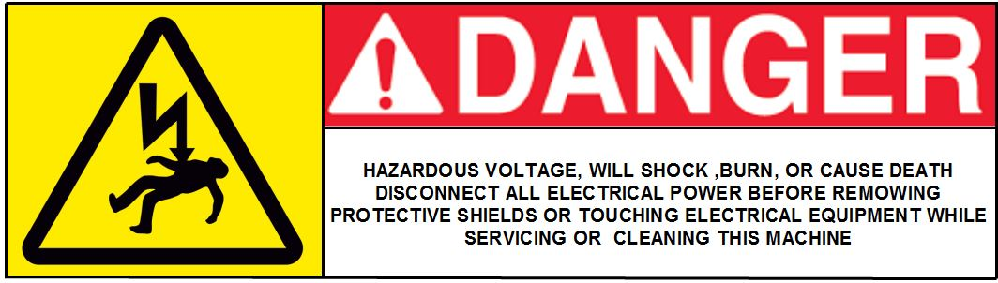

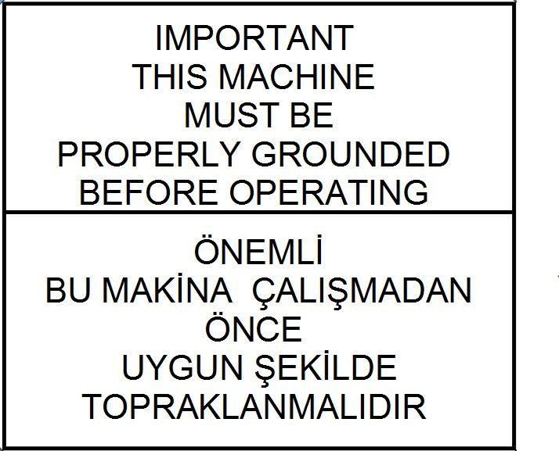

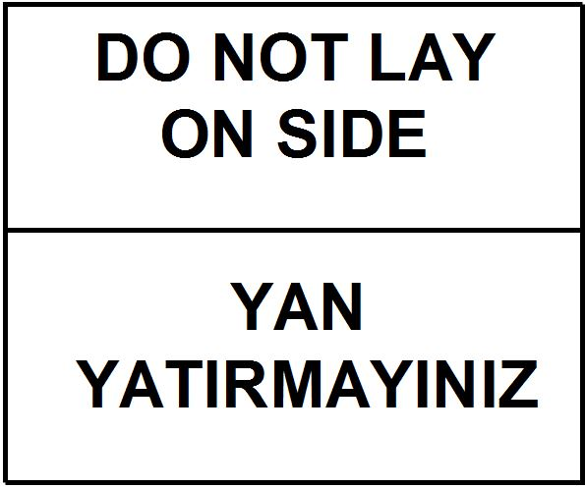

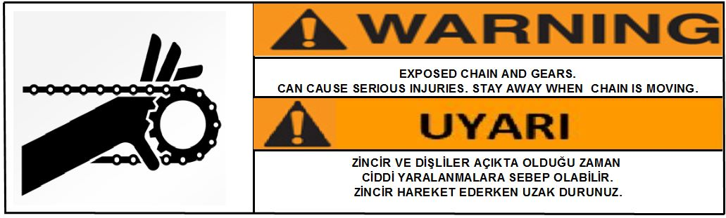

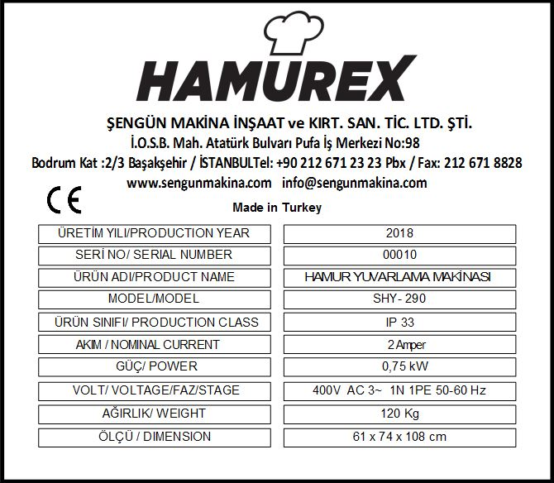
NOTE: Machine design and specifications may vary. Actual label design and location may vary without notice and may differ from the image shown.

ANTENTION: If safety labelsare lost, a new one should be replaced! Refer to dealer or Şengün Makina for replacement labels.

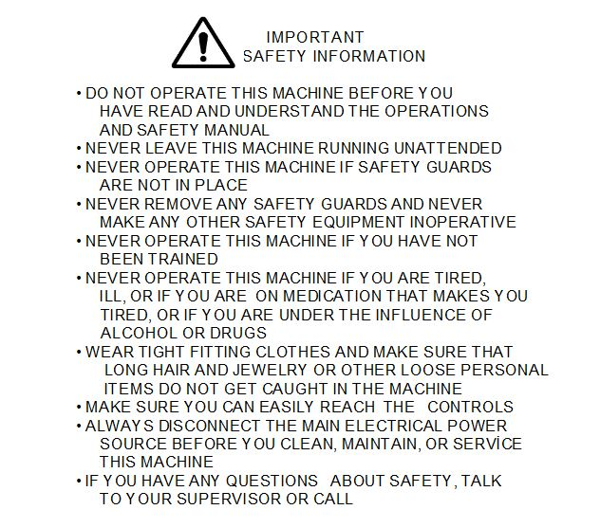
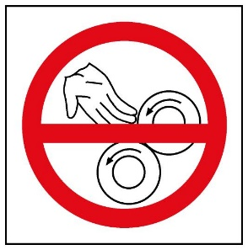

SECTION 4: SAFETY RULES

IMPORTANT

Read and follow these security guidelines. These rules will allow you to work safely.

- Read and follow these security rules. These are for you and your employees to work safely.
- Follow all instructions when using the machine.
- Replace the protective cover removed for maintenance and other reasons.
- Never operate the machine without training. Leave all protective covers in place.
- Do not operate the machine if you are sick or feeling unwell.
- Wear protective clothing before operating the machine. Do not use long hair, earrings and necklaces. May cause serious injury.
- Make sure you can easıly reach all controls. Otherwise, a stable and safe high platform or other work auxiliary installation must be provided.
- Make sure the power is off before cleaning the machine.
- Never leave the machine running.

IMPORTANT:

IF YOU HAVE ANY QUESTIONS ABOUT THIS SAFETY RULES, PLEASE CALL.
PHONE: +90 212 671 23 23

SECTION 5: INSTRUCTIONS FOR USE

WARNING

To prevent machine damage or personal injury, the unit must be operated properly and maintained properly.

FIRST OPERATION

A. Ensure that the drum, tray and conveyor are away from the packaging material, the rolling drum /funnel area must be free from the packaging material, packaging tapes, documents and other preventative materials.

B. Make sure the machine switch is in the off position.

C. Connect the power cord to an appropriate outlet.

D. Turn on the switch.

E. The rounding drum should be turning in a counter clock wise rotation.

NOTE:
If the machine (3) phase and direction of rotation are not correct, contact an experienced electrician.

- OPERATING THE MACHINE

The machine is ready to roll after.

A. Place the machine in the desired position and insert the two (2) locked wheels.
B. Connect the power cord to the appropriate electrical outlet.
C. Check if the rolling drum is turning correctly see the first start procedure for this.
D. Discard the cut dough pieces directly into the funnel. The dough will be rolled automatically and then it will be ensured that it will fall to the desired place thanks to the guiding blade.

WARNING:

Do not attempt operate this machine without reading the manual.

SECTION 6: CLEANING INSTRUCTIONS

All products of Şengün Makina are tested with dough in the company in preparation stage and within the framework of the quality control procedure. Although the machine has been cleaned, it is normal to see some dough residues on and inside.

All parts in contact with the dough should be cleaned after use. Usıng a mild soap and water solutıon. Removal of the machine for cleaning purposes is explained and shown in outline for your convenience.

The instructions in this manual indicate the need for regular ınspectıon and cleanıng to prevent ınfestatıon.

A. Caution: shut off all electrıcal power and unplug power cord.
B. Remove the dough routing sheet and dough input sheet (part number: 00276M, 00277M ).
C. Remove rounder spiral, using two people to lıft rounder spiral (part number: 05500)).
D. Remove the dough rounding bucket (part number: 05564).
E. Remove the spiral bottom washer (part number: 05561).
F. Remove excess dough from aluminum housing (part number: 05552)
G. Mounting is done in the form of the opposite of disassembly. (Steps from E to A)
H. Replace the spiral bottom washer.
I. Slide the drum over the rounding base so that the sliding slots are pushed into the sliding pins on the rounding base.
J. After entering the spiral, it is necessary to see that the output ramp on the spiral is facing the on/off button.

NOTE:
THE WATER TEMPERATURE SHOULD NOT exceed 190 ° C if the DOUGH BUCKET IS WHEN CLEANİNG. DO NOT PUT YOUR HANDS İN THE SPİRAL İF THE SPİRAL DOES NOT COME OUT.

A. Plug in the machine. Start the machine.
B. Add a small amount of warm water the contact area between screw and drum.
C. After the dough softens, turn off the machine.
D. Unplug the machine.
E. Raise the spiral with two people.

FIRST APPLICATION SAFETY

Always disconnect the power cord before cleaning the machine to avoid serious injury. Thus avoiding chance of serious injury. Machines are not dangerous if common sense is applied and the instructions are followed. First, apply the security policy.

SECTION 7: GENERAL MAINTENANCE MANUAL
Read and follow maintenance instructıons below to help keep the unit in good operatıng condition. For additional instructions on proper maintenance and service, refer to the other materials supplied with the machine and the manufacturers service manuals. Regular inspections and proper maintenance are essential to help prevent accidents and injuries.

FIRST APPLICATION SAFETY

Read any additional instructions for maintenance and service. Regular inspections will help prevent accidents and injuries that may occur. Thus, you eliminate the risk of serious injury. They are not dangerous when the machines are operated correctly and the instructions are followed. First, apply the security policy.

WARNING

Before performing a Inspection, adjustment, or repair, ensure that all moving parts are locked in the closed position of the power supply and machine switch to prevent injury. Wear protective clothing.

A. Make sure all fasteners are secure.
B. Make sure all protection covers are in place.
C. Check that there are worn, damaged and missing parts on the machine, including straps, safety enclosures, and protective covers.
D. Inspect the unit daily to make sure that all systems are functioning normally. Detailed examination and testing procedures for various components have been defined at regular intervals. Set up a chart and assing responsibility for these items.

CAUTION

Replace any damaged or missing safety labels. They are available from the manufacturer.

Maintenance of the machine always begins with the machine being kept clean. Proper cleaning procedures can be found on (12) page of this manual. Long term maintenance involves lubrication of main wear points.

All maintenance recommendations are for 7 days a day, 8 hour a day.

SECTION 8: MACHINE SPARE PARTS

IMPORTANT:

To maintain machine safety, performance and sanitary conditions, please only supply spare parts from the factory. Use of unapproved parts may void the manufacturers warranty.

Recognize your unit. To achieve maximum safety and performance, compare the diagrams in this guide to your unit.

FOR SPARE PARTS MANUAL ALWAYS:

  - Check for missing, damaged, or malfunctioning parts in the machine, including warning labels and instructions.

  - Compare the missing and defects list with the part diagram provided.

  - Save the model and serial number of the machine.

  - Call Şengün Makina +90212 6712323 to help you process your order and reduce shipping costs ve yukarıda not edilen tüm bilgileri temin edin and supply all information written above.

  - Please provide all information about the invoice address and delivery location. Specify the preferred means of transport to assist in rapid delivery.

  - Most of the credit cards accepted are accepted.

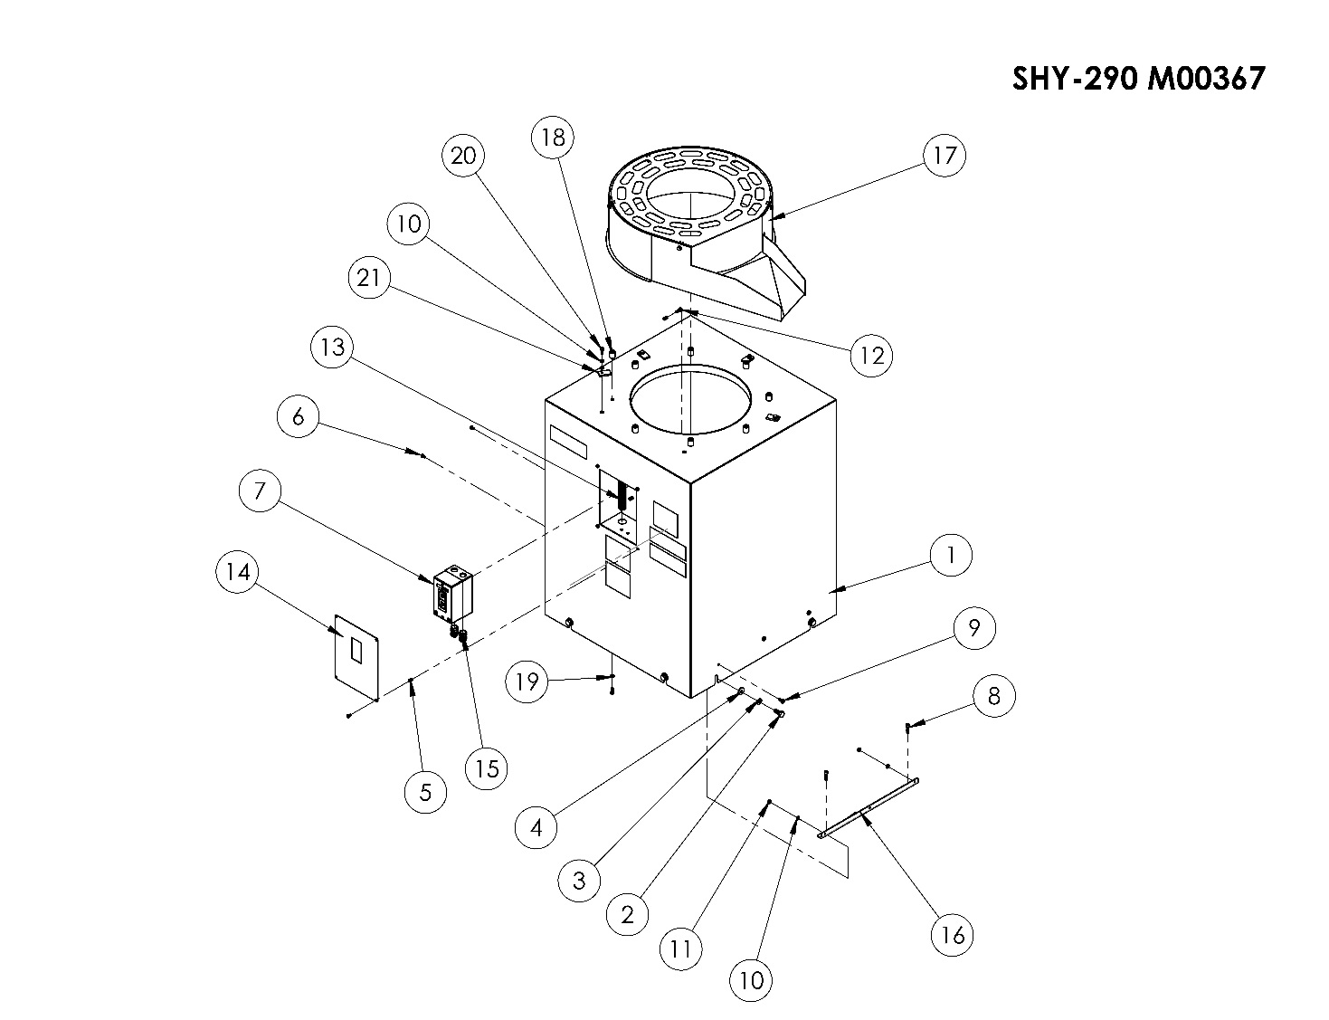
SHY-290 M00367 SPARE PARTS LIST
ITEM | SPARE PARTS NUMBER | SPARE PARTS DESCRIPTION |  | UNIT |  | ITEM | SPARE PARTS NUMBER | SPARE PARTS DESCRIPTION |  | UNIT
1 | 00275M | BODY SHEET |  | 1 |  | 12 | 08075 | BOLT |  | 4
2 | 04072 | BOLT |  | 8 |  | 13 | 05550 | SPIRAL PIPE |  | 2
3 | 05528 | DISTANCE RING |  | 8 |  | 14 | 05565 | ELECTIRCAL COVER |  | 1
4 | 05542 | WASHER |  | 8 |  | 15 | 05566 | RECORD |  | 2
5 | 00335 | FIX |  | 14 |  | 16 | 05540 | BODY ADJUSTMENT CORNER |  | 2
6 | 00046 | BOLT |  | 6 |  | 17 | 00276M | DOUGH ROUTING SHEET |  | 1
7 | 05544 | SWITCH |  | 1 |  | 18 | 05572 | SHEET CENTERING PIN |  | 8
8 | 04078 | BOLT |  | 4 |  | 19 | 01817 | WASHER |  | 8
9 | 05548 | BOLT |  | 6 |  | 20 | 03089 | BOLT |  | 8
10 | 04080 | DISTANCE RING |  | 6 |  | 21 | 05575 | ROUTING SHEET HOLDER |  | 4
11 | 03086 | NUT |  | 6

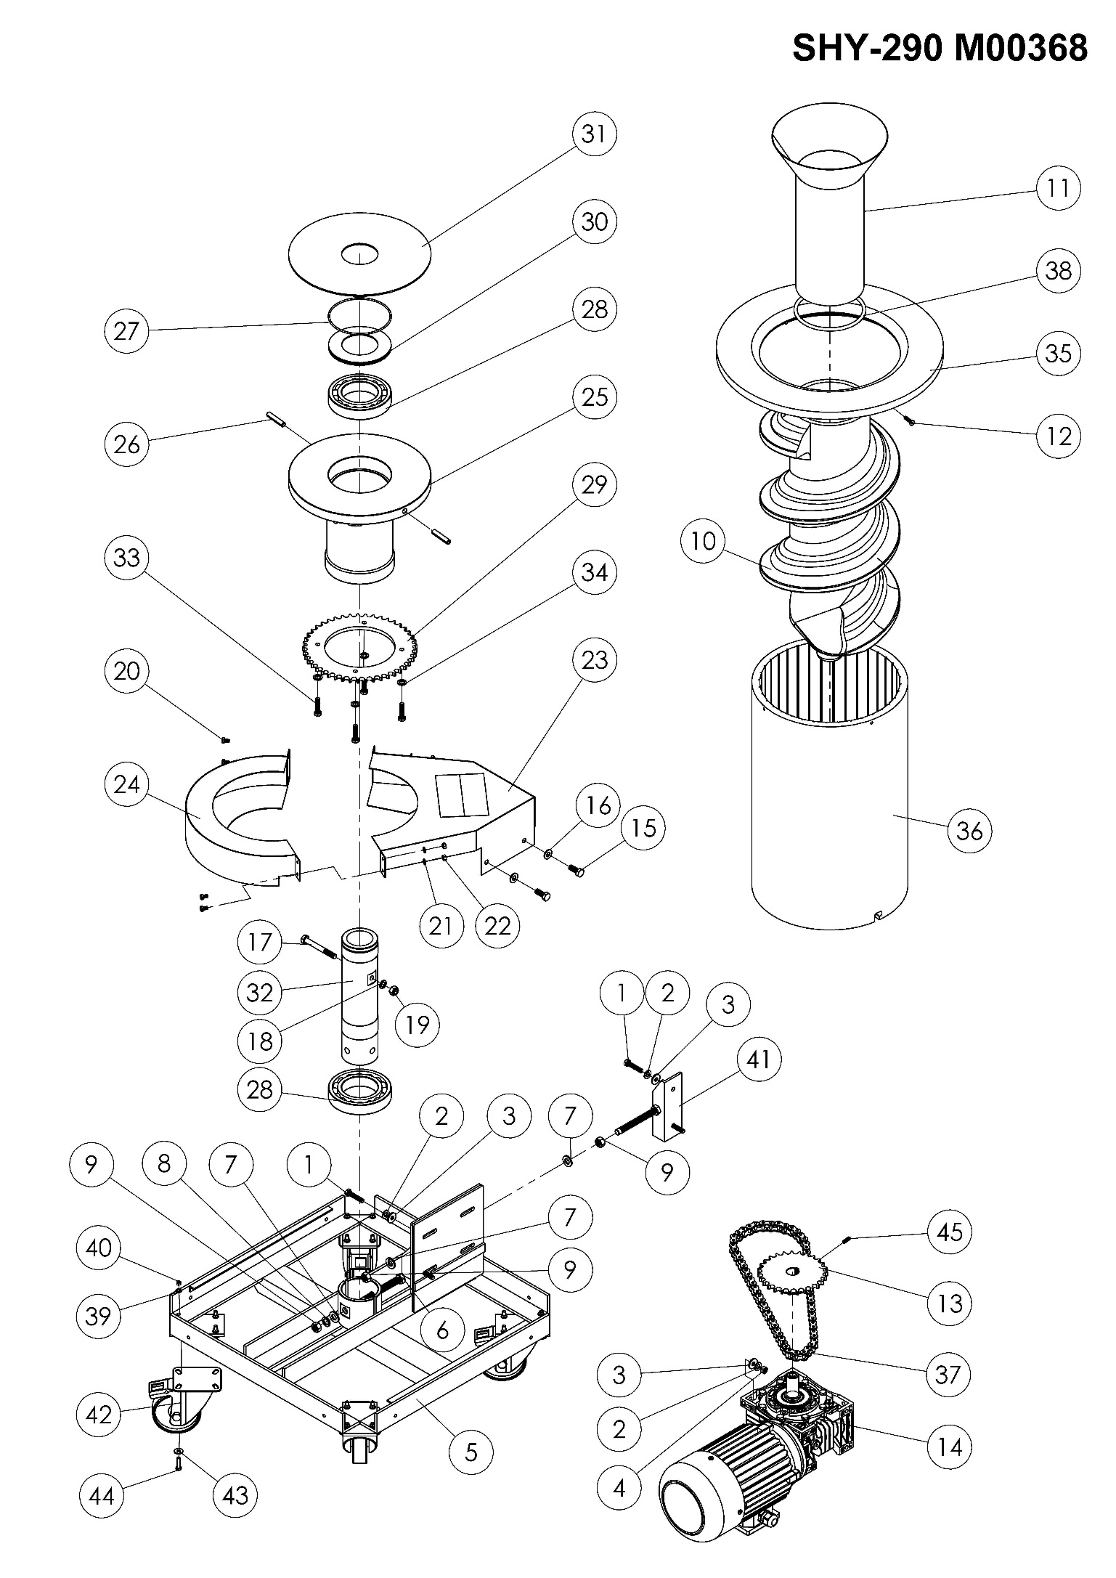

SHY-290 M00368 SPARE PARTS LIST
ITEM | SPARE PARTS NUMBER | SPARE PARTS DESCRIPTION |  | UNIT |  | ITEM | SPARE PARTS NUMBER | SPARE PARTS DESCRIPTION |  | UNIT
1 | 05527 | BOLT  AKB" |  | 4 |  | 25 | 05552 | HIVE |  | 1
2 | 05528 | DISTANCE RING |  | 8 |  | 26 | 05553 | FISSURED PIN |  | 2
3 | 05529 | WASHER |  | 8 |  | 27 | 05557 | ORING |  | 1
4 | 05530 | NUT |  | 4 |  | 28 | 05558 | ROLLER |  | 2
5 | 00274M | CHASSIS |  | 1 |  | 29 | 05559 | HEAR CHAIN GEAR |  | 1
6 | 05537 | BOLT |  | 1 |  | 30 | 05560 | ORING WASHER |  | 1
7 | 06022 | WASHE |  | 3 |  | 31 | 05561 | SPIRAL LOWER WASHER |  | 1
8 | 02571 | DISTANCE RING |  | 1 |  | 32 | 05562 | HIVE SHAFT |  | 1
9 | 02570 | NUT |  | 3 |  | 33 | 04070 | BOLT |  | 4
10 | 05541 | SPIRAL |  | 1 |  | 34 | 01961 | DISTANCE RING |  | 4
11 | 00277M | DOUGH INPUT SHEET |  | 1 |  | 35 | 05563 | ROUND BUCKET BRACELET |  | 1
12 | 05500 | BOLT |  | 4 |  | 36 | 05564 | ROUND BUCKET |  | 1
13 | 05545 | REDUCER CHAIN GEAR |  | 1 |  | 37 | 05567 | CHAIN |  | 1
14 | 05547 | ENGINE |  | 1 |  | 38 | 05556 | ORING |  | 1
15 | 00279 | BOLT |  | 2 |  | 39 | 00042 | DISTANCE RING |  | 16
16 | 00277 | WASHER |  | 2 |  | 40 | 02581 | NUT |  | 16
17 | 05546 | BOLT |  | 1 |  | 41 | 00272M | ENGİNE CHASSIS |  | 1
18 | 01960 | DISTANCE RING |  | 1 |  | 42 | 05511 | CHASSIS WHEEL |  | 4
19 | 03173 | NUT |  | 1 |  | 43 | 01299 | WASHER |  | 16
20 | 02635 | BOLT |  | 4 |  | 44 | 00556 | BOLT |  | 16
21 | 04080 | DISTANCE RING |  | 4 |  | 45 | 00121 | STAY BOLT |  | 2
22 | 03086 | NUT |  | 4
23 | 00281M | GEAR CASİNG SHEET |  | 1
24 | 00280M | GEAR CASİNG SHEET |  | 1

SECTION 9: ELECTRICAL DIAGRAM

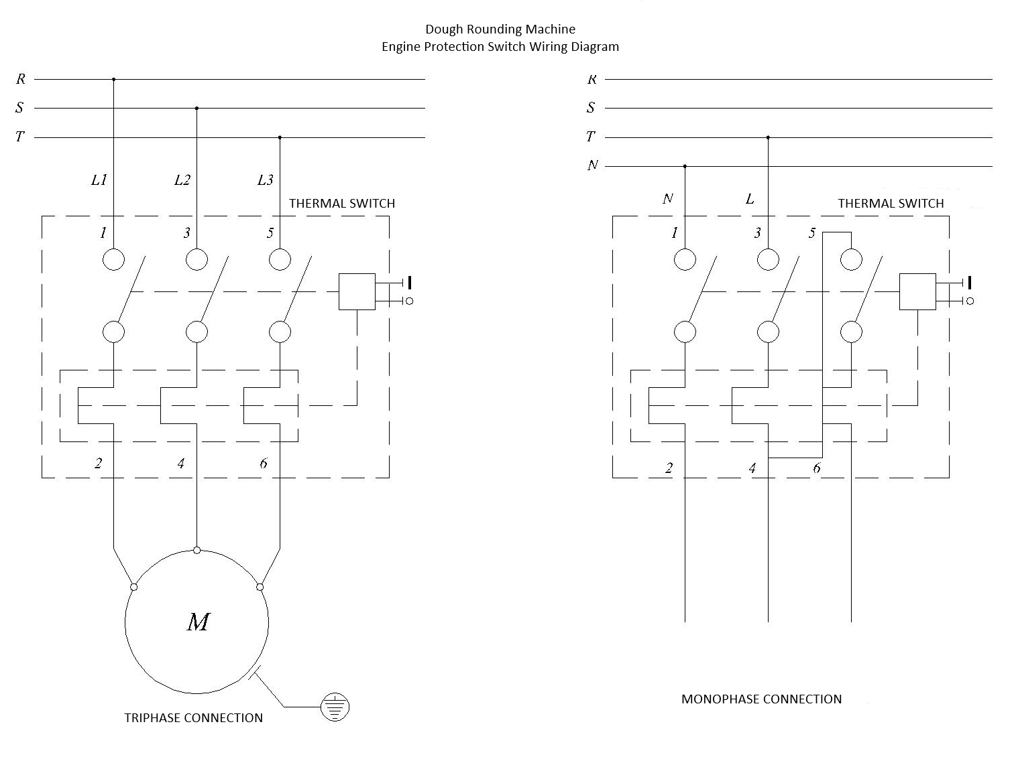


ŞENGÜN MAKİNA İNŞAAT and KIRTASİYE SAN. TİC. LTD. ŞTİ.
İkitelli Organized Area, Atatürk Boulevard, Pufs Business center, No: 98 Basement Floor: 2-3
Başakşehir/ İstanbul/ Türkiye

Phone: +90 212 671 23 23 (Pbx)
Phone 2: +90 212 671 84 84
Fax: +90 212 671 88 28
GSM: +90 533 957 14 53

e-Mail : usta@hamurex.com.tr
web : www.hamurex.com.tr

